Project Development Phase
Model Performance Test

Date | 8 September 2026
Team ID | SWUID2026190365
Project Name | ServiceNow-Based Employee Laptop Request Application
Maximum Marks

Model Performance Testing:
Project team shall fill the following information in model performance testing template.
S.No. | Parameter | Values | Screenshot
1. | ServiceNow Application Summary | Centralized employee laptop request application using Employee Center, Record Producer, Flow Designer, Business Rule, ACLs and email notifications. | 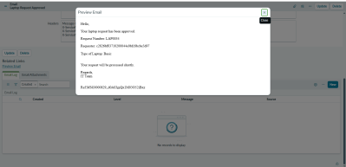
2.. | Workflow Accuracy | Approval outcome correctly updates request status to Approved or Rejected. | 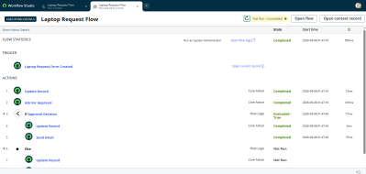
3. | Fine Tunning Result( if Done) | Not Applicable – this is a ServiceNow workflow application, not an AI/ML model. | N/A

Functional & Performance Testing Template
Model Performance Test

Date | 8 September 2026
Team ID | SWUID2026190365
Project Name | ServiceNow-Based Employee Laptop Request Application
Maximum Marks

Test Scenarios & Results
Test Case ID | Scenario (What to test) | Test Steps (How to test) | Expected Result | Actual Result | Pass/Fail
FT-01 | Laptop request form validation | Enter valid requester, email, date, manager, type and reason. | Valid request data is accepted. | Valid laptop request was submitted successfully and the request record was created. | Pass
FT-02 | Required field validation | Leave required fields blank and submit. | Submission is prevented and validation is shown. | Submission was prevented when required information was missing. | Pass
FT-03 | Manager approval workflow | Submit a valid laptop request and check approval. | Manager approval record is created. | Manager approval record was created successfully for the submitted request. | Pass
FT-04 | Approval decision handling | Approve and reject requests in separate tests. | Status becomes Approved or Rejected accordingly. | Request status changed to Approved when approved and Rejected when rejected. | Pass
FT-05 | Duplicate request prevention | Submit another request for the same employee in the same year. | Duplicate request is blocked. | Duplicate request was blocked with the duplicate-request validation message. | Pass
PT-01 | Flow execution performance | Measure the request-to-approval workflow execution. | Workflow completes successfully without unnecessary delay. | Flow executed successfully from request creation through manager approval and status update. | Pass
PT-02 | Notification performance | Trigger approval and rejection outcomes. | Requester notification is generated successfully. | Email notification was generated successfully after the approval/rejection outcome. | Pass

Project Development Phase
Model Performance Test

Date | 8 September 2026
Team ID | SWUID2026190365
Project Name | ServiceNow-Based Employee Laptop Request Application
Maximum Marks | 10 Marks

Model Performance Testing:
Project team shall fill the following information in model performance testing template.
S.No. | Parameter | Values | Screenshot
 | Metrics | Not Applicable – ServiceNow workflow application; no regression/classification ML model is used. | N/A
 | Tune the Model | Not Applicable – no ML model or hyper parameter tuning is used. | N/A

Project Development Phase
Model Performance Test

Date | 8 September 2026
Team ID | SWUID2026190365
Project Name | ServiceNow-Based Employee Laptop Request Application
Maximum Marks

Model Performance Testing:
Project team shall fill the following information in model performance testing template.
S.No. | Parameter | Screenshot / Values
1. | Data Rendered | ServiceNow laptop request records are rendered in list and form views.
2. | Data Preprocessing | Not applicable – ServiceNow manages request records directly.
3. | Utilization of Data Filters | Status, requester, laptop type and request date can be filtered.
4. | DAX Queries Used | Not Applicable – Power BI is not used in this project.
5. | Dashboard design | Not Applicable – ServiceNow application views are used.
6 | Report Design | Not Applicable – no Power BI report is used.

Project Development Phase
Model Performance Test

Date | 8 September 2026
Team ID | SWUID2026190365
Project Name | ServiceNow-Based Employee Laptop Request Application
Maximum Marks

Model Performance Testing:
Project team shall fill the following information in model performance testing template.
S.No. | Parameter | Values | Screenshot
 | Application Summary | ServiceNow automation setup for centralized employee laptop requests using Record Producer, Flow Designer, Business Rule, ACLs and notifications. | 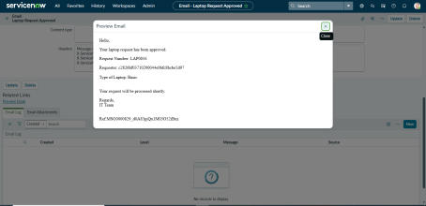
 | Workflow Result | Approved requests become Approved; rejected requests become Rejected; duplicate requests are blocked. | 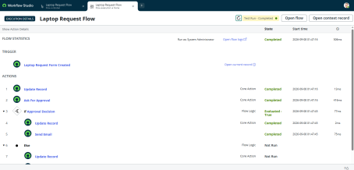
3. | Confidence Score (Only Yolo Projects) | Not Applicable – this is not a YOLO/object-detection project. | N/A

Project Development Phase
Performance Test

Date | 8 September 2026
Team ID | SWUID2026190365
Project Name | ServiceNow-Based Employee Laptop Request Application
Maximum Marks

Model Performance Testing:
Project team shall fill the following information in model performance testing template.
S.No. | Parameter | Screenshot / Values
 | Data Rendered | ServiceNow laptop request records are rendered in list and form views.
 | Data Preprocessing | Not applicable – ServiceNow handles the request data directly.
3. | Utilization of Filters | Filters can be applied using requester, status, laptop type and request date.
4. | Calculation fields Used | Not Applicable – Tableau is not used in this project.
5. | Dashboard design | Not Applicable – no Tableau dashboard is used.
6 | Story Design | Not Applicable – no Tableau story is used.

User Acceptance Testing (UAT) Template
Date | 8 September 2026
Team ID | SWUID2026190365
Project Name | ServiceNow-Based Employee Laptop Request Application
Maximum Marks

1. Purpose of Document
The purpose of this document is to briefly explain the test coverage and open issues of the ServiceNow-Based Employee Laptop Request Application project at the time of release to User Acceptance Testing (UAT).
The testing covers the laptop request form, required field validation, manager approval workflow, approval decision handling, duplicate request prevention, workflow performance, and email notifications.

2. Defect Analysis
This report shows the number of resolved or closed defects at each severity level and how they were resolved.
Resolution | Severity 1 | Severity 2 | Severity 3 | Severity 4 | Subtotal
By Design | 0 | 0 | 0 | 0 | 0
Duplicate | 0 | 0 | 0 | 0 | 0
External | 0 | 0 | 0 | 0 | 0
Fixed | 0 | 0 | 0 | 0 | 0
Not Reproduced | 0 | 0 | 0 | 0 | 0
Skipped | 0 | 0 | 0 | 0 | 0
Won't Fix | 0 | 0 | 0 | 0 | 0
Totals | 0 | 0 | 0 | 0 | 0
Defect Summary: No unresolved defects were identified during the project testing. The implemented functional requirements were successfully tested.

3. Test Case Analysis
This report shows the number of test cases that have passed, failed, and not been tested for the ServiceNow-Based Employee Laptop Request Application.
Section | Total Cases | Not Tested | Fail | Pass
Laptop Request Form | 2 | 0 | 0 | 2
Manager Approval Workflow | 2 | 0 | 0 | 2
Duplicate Request Prevention | 1 | 0 | 0 | 1
Workflow Performance | 1 | 0 | 0 | 1
Email Notification | 1 | 0 | 0 | 1
Total | 7 | 0 | 0 | 7

Test Case Details
Test Case ID | Scenario | Expected Result | Actual Result | Status
FT-01 | Laptop request form validation | Valid request data is accepted. | Valid laptop request was submitted and record was created successfully. | Pass
FT-02 | Required field validation | Submission is prevented when required fields are missing. | Submission was prevented when required information was missing. | Pass
FT-03 | Manager approval workflow | Manager approval record is created. | Manager approval record was created successfully. | Pass
FT-04 | Approval decision handling | Status changes to Approved or Rejected according to manager decision. | Request status changed correctly to Approved or Rejected. | Pass
FT-05 | Duplicate request prevention | Duplicate request is blocked. | Duplicate request was blocked with the validation message. | Pass
PT-01 | Flow execution performance | Workflow completes successfully without unnecessary delay. | Flow executed successfully from request creation through approval and status update. | Pass
PT-02 | Notification performance | Requester notification is generated successfully. | Email notification was generated successfully after the approval/rejection outcome. | Pass

Final Test Result
Total Test Cases: 7
Passed: 7
Failed: 0
Not Tested: 0
Overall Test Status: PASS

